Question 1:

.data

msg1: .asciiz "Enter a Number: "

msg2: .asciiz "Reversed Number: "

.text

li $v0, 4

la $a0, msg1

syscall

li $v0, 5

syscall

move $t0, $v0

li $t1, 0

li $t3, 10

loop: ble $t0,$zero, exit

div $t0, $t3

mfhi $t2

mul $t4,$t1, $t3

add $t1,$t4, $t2

div $t0,$t0, 10

b loop

exit: li $v0, 4

la $a0, msg2

syscall

li $v0, 1

la $a0, ($t1)

syscall

li $v0, 10

syscall

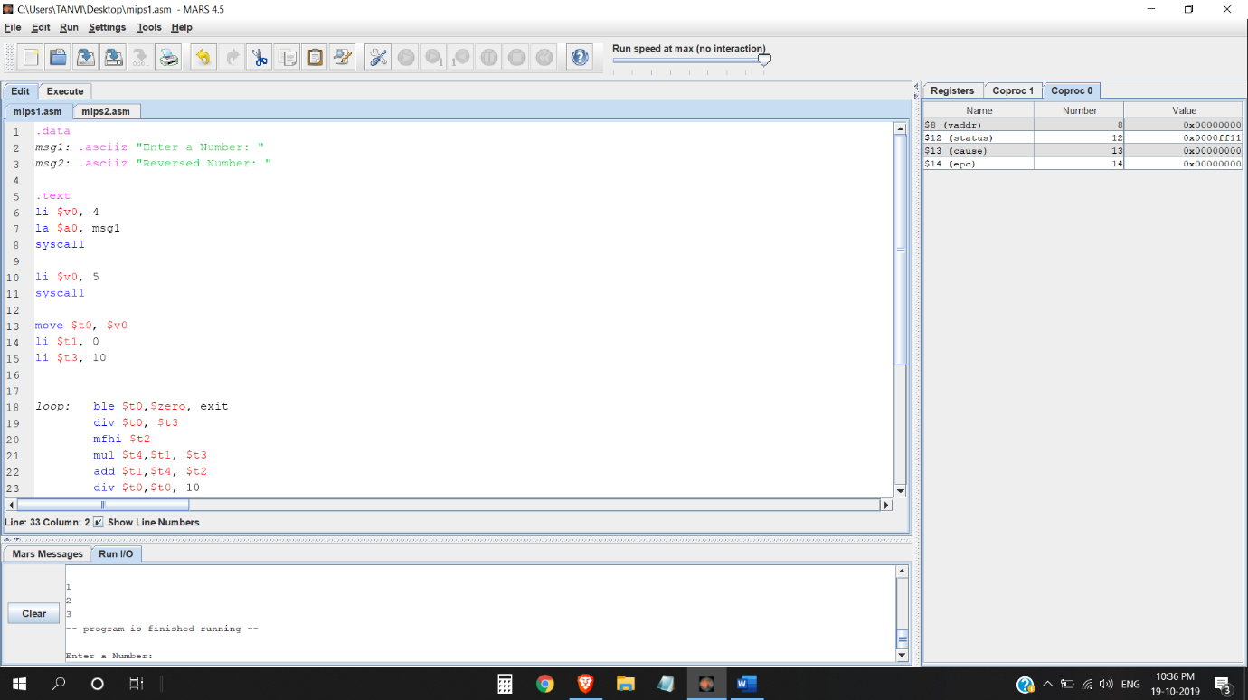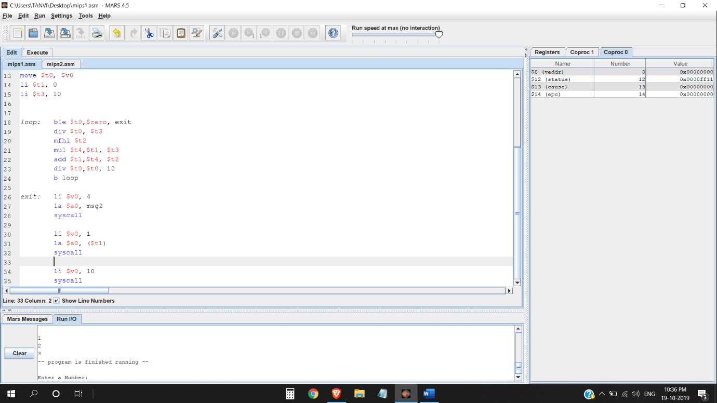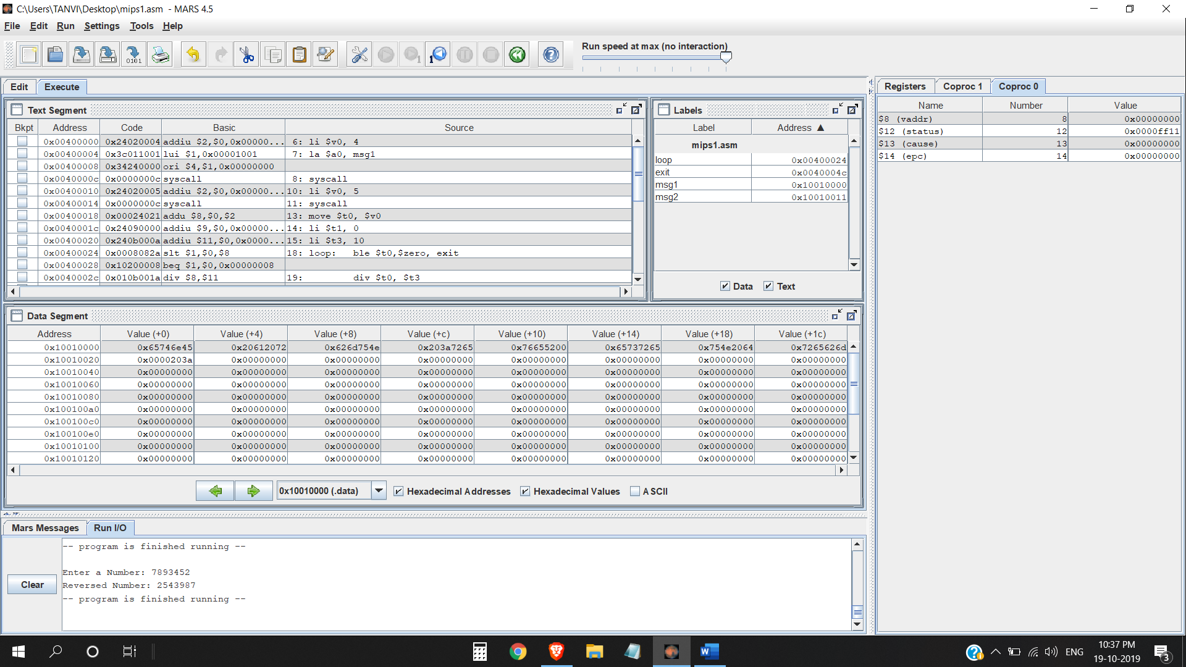

Question 2:

.data

msg: .asciiz "\n"

.text

main: li $t0, 1

li $t1, 3

li $t2, 0

loop: bgt $t0,$t1, return

li $v0, 4

la $a0, msg

syscall

li $v0, 1

la $a0, ($t0)

syscall

addi $t0,$t0, 1

b loop

return:

li $v0, 10

syscall

